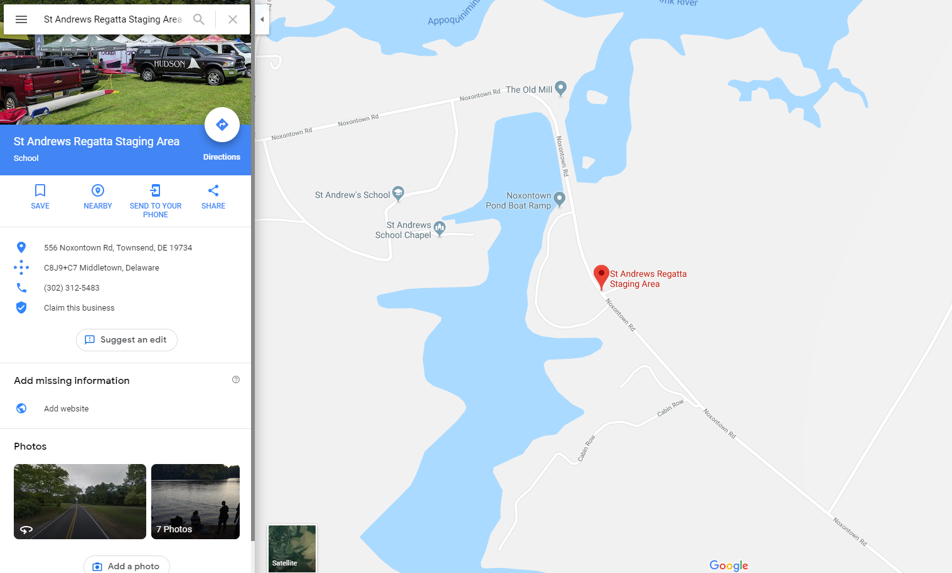

***Additional Helpful Regatta Information:***

* Athletes should eat a good breakfast before departure and/or bring snacks for bus.
* The team will offer light breakfast upon arrival; all efforts will be concentrated on unloading, derigging and practice.
* Lunch will be provided and available as time permits between warm ups and races. Grilled burgers will be available.
* Parents should see SUG for other items needed and available to rowers and spectators with team.
* The team tent will be available but remember to bring a lawn chair or blanket for sitting.
* Be prepared for changing weather – hot and cold. As we saw last weekend with cancellation, anything can happen.
* **Regatta questions???:** Feel free to call Barbara Benedict at 813.449.3073.

***REGATTA FAST FACTS:***

* **The Venue - Boathouse address:**
  + 600 Noxontown Road, Middletown, DE 19734
  + Estimated 2:15-2:30 hour ride dependent on traffic.
  + Location is not accessed by driving onto the school campus
* **Parking:**
  + FREE: parking is available at the Noxontown Pond area near the team tents
* **Facilities:**
  + Race site offers only port-a-johns.
  + There is very little shelter.
  + No potable water onsite.
* **Racing Starts:**
  + 1:00 PM
* **Rowers Should Bring:**
  + Rowers should wear what they are going to practice in on bus.
  + Crew Uni and long sleeve top for racing
  + Layers of clothes and rain gear
  + Change of clothes for ride home

**Bus and Rowing Schedule:**

**Rowers will travel on two commercial tour buses. Coaches/chaperones will ride in each bus**.

6:30 AM – Buses arrives at MHS for loading

* *Eat breakfast before loading or bring snack for ride.*

6:45 AM – Last **call… All rowers at bus for loading**

7:00 AM – Buses departs MHS

9:00-9:30 AM – Buses arrives St. Andrews

**After arrival:**

* Unload and rig boats
* Practice
* Athletes stretch and eat

RACES BEGIN AT 1:00 PM

4:00 PM – Buses arrives St. Andrews for loading

4:30 PM – Buses depart St. Andrews for McLean

7:00-7:30 PM – Buses return to MHS