Row for the Red
McLean Crew Ergathon
When: Saturday, February 10, 2024 10 a.m. – 2 p.m.

Where: McLean CVS
(1452 Chain Bridge Rd)
Support our student athletes by donating to McLean Crew!

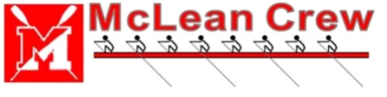

ERGATHON DONATION FORM Hand in this
form with donations at practice on February 7th.
Athlete Name: ________________________________
SPONSOR  Family Member? (Y/N) | ADDRESS  Mailing address, or email | $ AMOUNT
TOTAL AMOUNT

Print another copy of the form if you need more space.
DIRECTIONS:
● Start seeking donations on 1/8/2024.
● Turn in all donations in a regular envelope, labeled with your name and “Erg-a-thon”.
● The envelope should contain all donations and this donation form.
● Please condense all cash received into a single check. For example, if five people give you $20 each, their information should be entered above, and before turning in your envelope with this form, write a check to "McLean Crew Club" for the $100 donated; whoever wrote the check then keeps the $100 cash. Direct Questions to the Ergathon Coordinator:

Anne Butler - aejoslove5@gmail.com

Additional Donations Form:

SPONSOR | ADDRESS | AMOUNT
Total Amount

